**Q1**

1.C 2.A 3.B 4.D 5.D

**Q2**

1. Let MOSFET work in the triode region.

①Simple manufacturing process; ②High input impedance

2. Its working principle flow is the control circuit to control the operation of the whole system, the inverter circuit to complete the conversion from direct current to alternating current function, the filter circuit is used to filter out unwanted signals.

* Its DC voltage drop is small, which lowers the operating supply voltage, while its equivalent dynamic resistance is large. In addition, MOSFETs can reduce power consumption.

**Q3**

(a)neither (b)enhancement (c)neither (d)depletion

**Q4.**

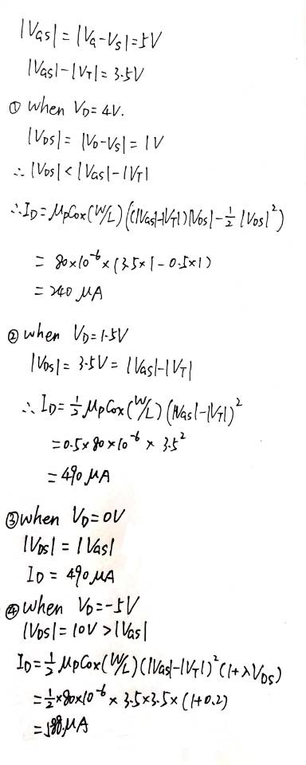

**Q5.**

